Week 8 Homework (30 pts)

1. Problem 1 (6 pts). Use ASPE to solve 13-7.2. You don’t need to do parts (a)-(c).

Solution:

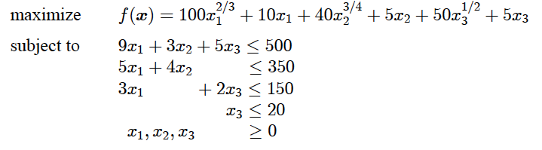

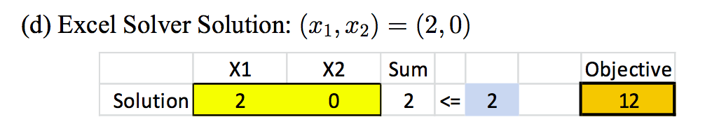

1. Problem 2 (6 pts). Do parts (a)-(c) of 13-7.6. Include a picture of the spreadsheet here (or paste the spreadsheet directly into the document) and describe any differences, if any, between the two solver approaches. (Note, this solution is wrong, but you can still get the basic idea. The interaction term should be 10 S_1 S_2 not 5 S_1 S_2.)

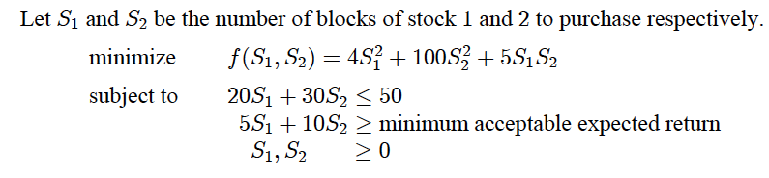

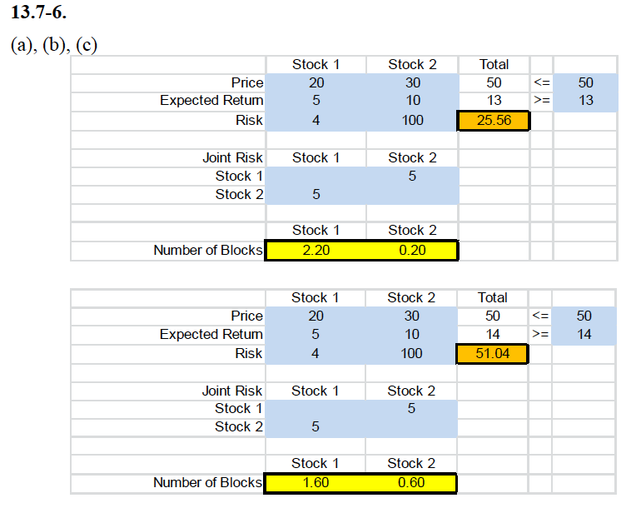

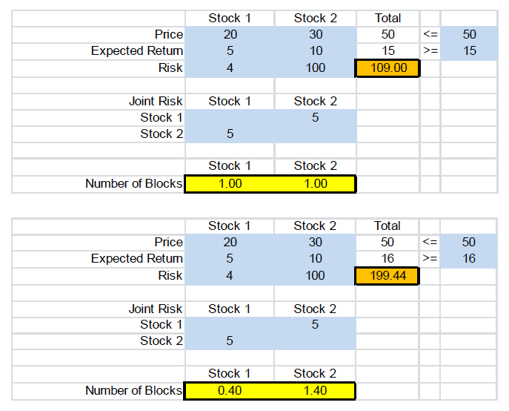

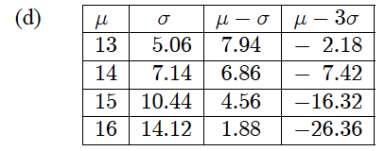

1. Problem 3 (6 pts). Use OPL to solve the quadratic program in problem 13.7-7. You do not need to do parts (a)-(d). Instead, include the OPL file here as well as the output. A sample quadratic program, qpex1.mod file from the IBM documentation, is included in the download packet. Alternately, you can install the qpex1 example in CPLEX Studio.

Solution: (mod file is in solution folder also)

/* QP:

* Problem 13.7-7 from Hillier text

*/

range R = 1..2;

dvar float+ x[R] in 0..40;

maximize

200*x[1]-100*x[1]^2+300*x[2]-100*x[2]^2;

subject to {

ct1: x[1] + x[2] <= 2;

}

Maximum profit is $312.50 per hour and occurs when product 1 is produced at 0.75 units per hour and product 2 is produced at 1.25 units per hour.

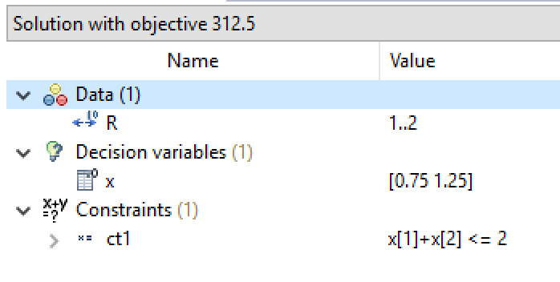

1. Problem 4 (6pts). As a warmup to next week do problem 13.10-5. We’ll learn more about multistart and evolutionary algorithms next week. Include spreadsheet (or image of spreadsheet) here. Did you notice any differences between the solvers?

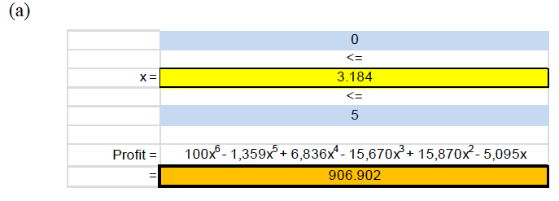

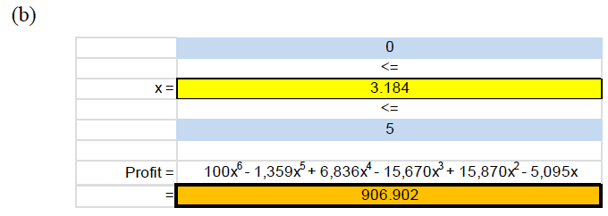

1. Problem 5 (6pts). Solve 13.1-2 using the GRG Solver in ASPE. This is an example of a convex objective function, but proving that is beyond our scope. You’ll have to formulate the profit function, but to give you an idea the profit due to selling x1 units of product 1 is (35+100 x1^(-1/3) ) * x1 – 25 x1 … you fill in the rest.

